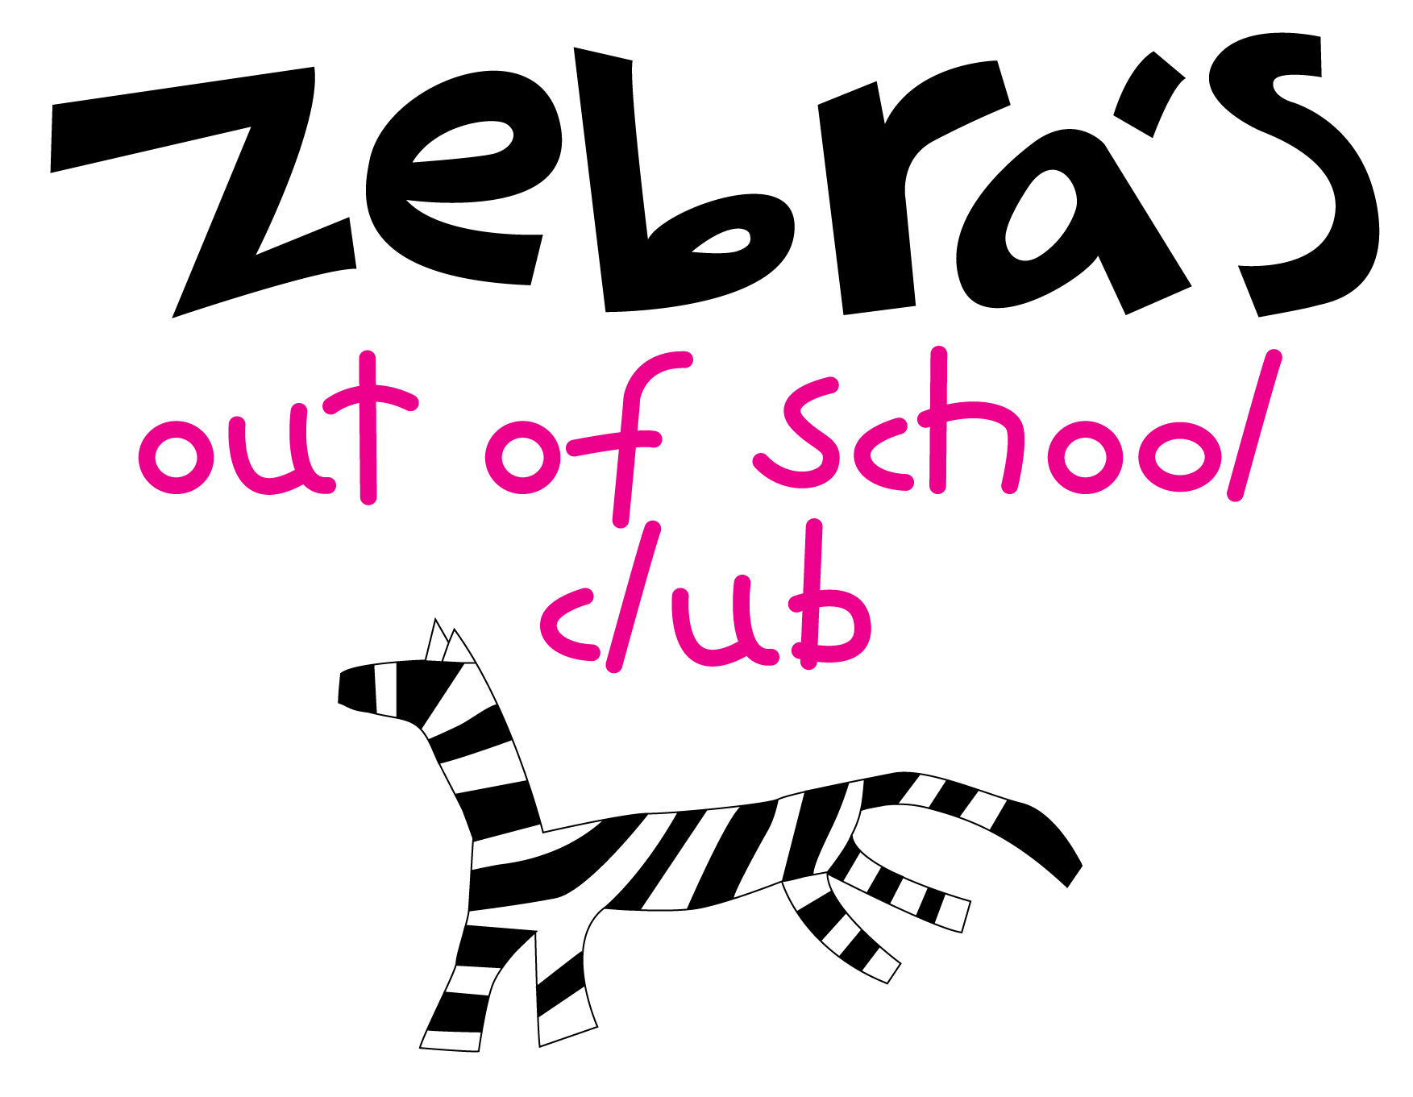

Playworker Job Description

General Duties:
- To be punctual, reliable and act in a professional and responsible manner, at all times, while the playscheme is in operation.
- To ensure all policies and procedures are read, understood and implemented.
- To work as part of a team, supervising and managing play and activities throughout the session. This involves setting up (laying out resources), cleaning/sanitising and tidying the play environment at the end of each session. Preparing and serving snacks (as needed). Supervising and interacting with children (inside/outside) and during offsite trips (where applicable).
- To contribute proactively and practically to the safe running of Zebras, by conducting safety checks and reporting any issues to your manager.
- To contribute to the collection of data, recording information and maintaining records as needed (registers/daily checklists/accident/ incident forms)
- To understand Zebras commitment to safeguarding and implement our safeguarding policies and procedures.
- To apply anti-discriminatory and anti-oppressive practice at all times and becoming familiar with Zebras Inclusion/Equalities Policies.
- To be responsive to a range of play types, behaviours and experiences, allowing children control and autonomy over the content and intent of their play, whilst challenging behaviour in children that affects the experience and enjoyment of others.
- To promote and encourage child participation within all areas of the play setting.
- To demonstrate a commitment to and participate in playwork reflective practice, both individually and as a team, to include staff meetings and debriefing of sessions.
- To act as a positive ambassador for Zebras and not saying or doing anything that would bring the organisation into disrepute.
- To receive induction, regular supervision and essential training, incorporating learning into the job.

Professional Development:
- To undertake a period of induction, including compulsory Child Protection training
- Willingness to undertake relevant training opportunities as required (Food Hygiene/Paediatric First Aid/EYFS)
- To attend and participate in personal development meetings (with manager), evaluating your own practice and identifying targets.
- Contribute to the quality assurance of Zebras through continuous reflection of own practice and the collection of play-based evidence.

Lyn Collins/March 2022

Zebras Out of School Club Ltd is a company limited by guarantee: Company Number 08148943.
Registered office: Cotham School, Cotham Lawn Road, Bristol BS6 6DT

